Netbeans with JDK 8

1. Browse to URL <http://www.oracle.com/technetwork/articles/javase/jdk-netbeans-jsp-142931.html>. Please be sure to select the option that bundles the JDK with NetBeans, it will make your life significantly easier!

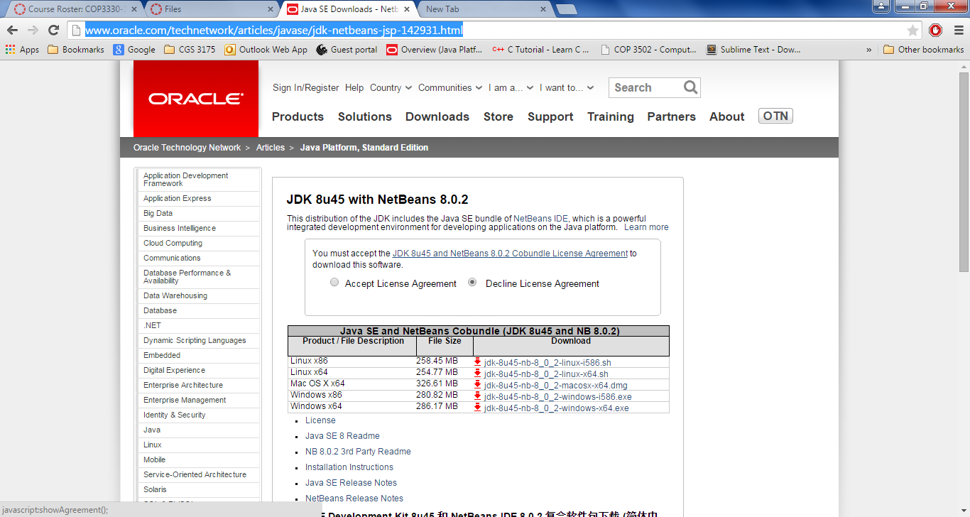

1. Accept License Agreement
2. Click the link for your operating system.



1. Click the installer executable.

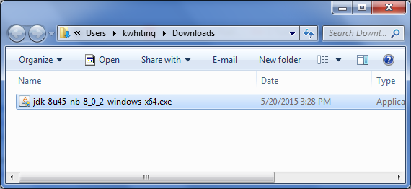

1. Click the Next button

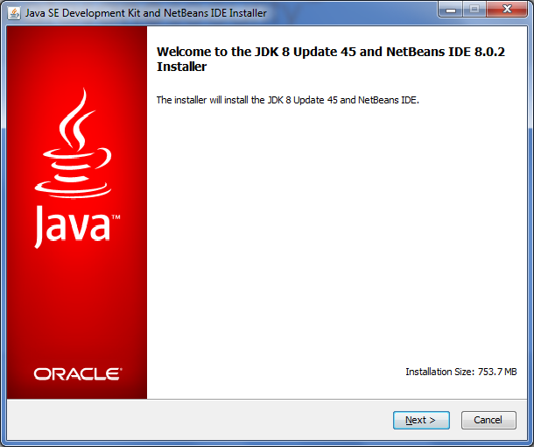

1. Accept the license agreement, click Next

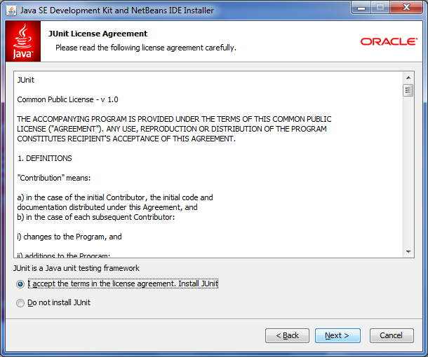

1. Select the Destination Folder then click the Install button.

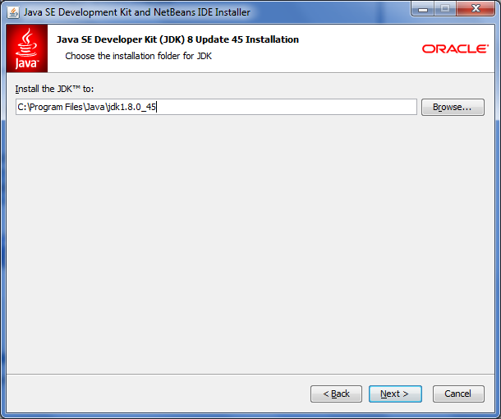

1. Link to the JDK folder location, click Next

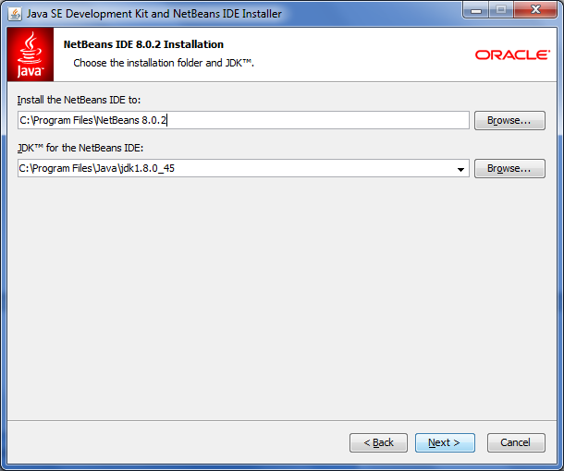

1. Click Install

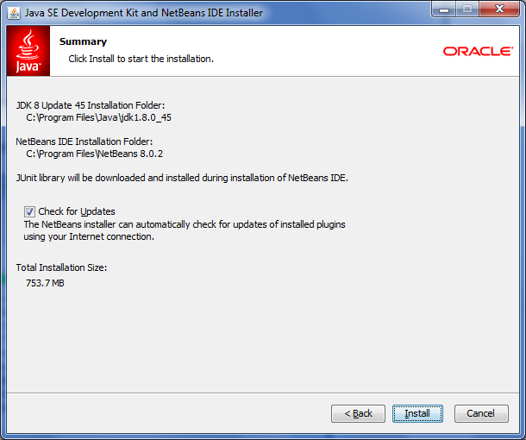

1. Installation view

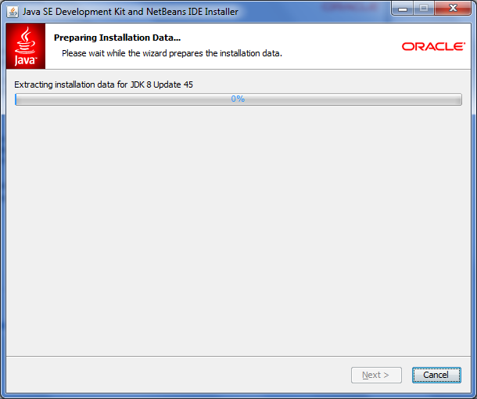

1. Click the Finish button.

